CS 255 System Design Document Template

This template lays out all the different sections that you need to complete for Project Two. Each section has guidance to prompt your thinking. You will need to continually reference the interview transcript as you work to make sure that you are addressing your client’s needs. There is no required length for the final document. Instead the goal is to complete each section based on what your client’s needs are. Remove this note when you are finished, and replace all bracketed text with the relevant information.

UML Diagrams

UML Use Case Diagram
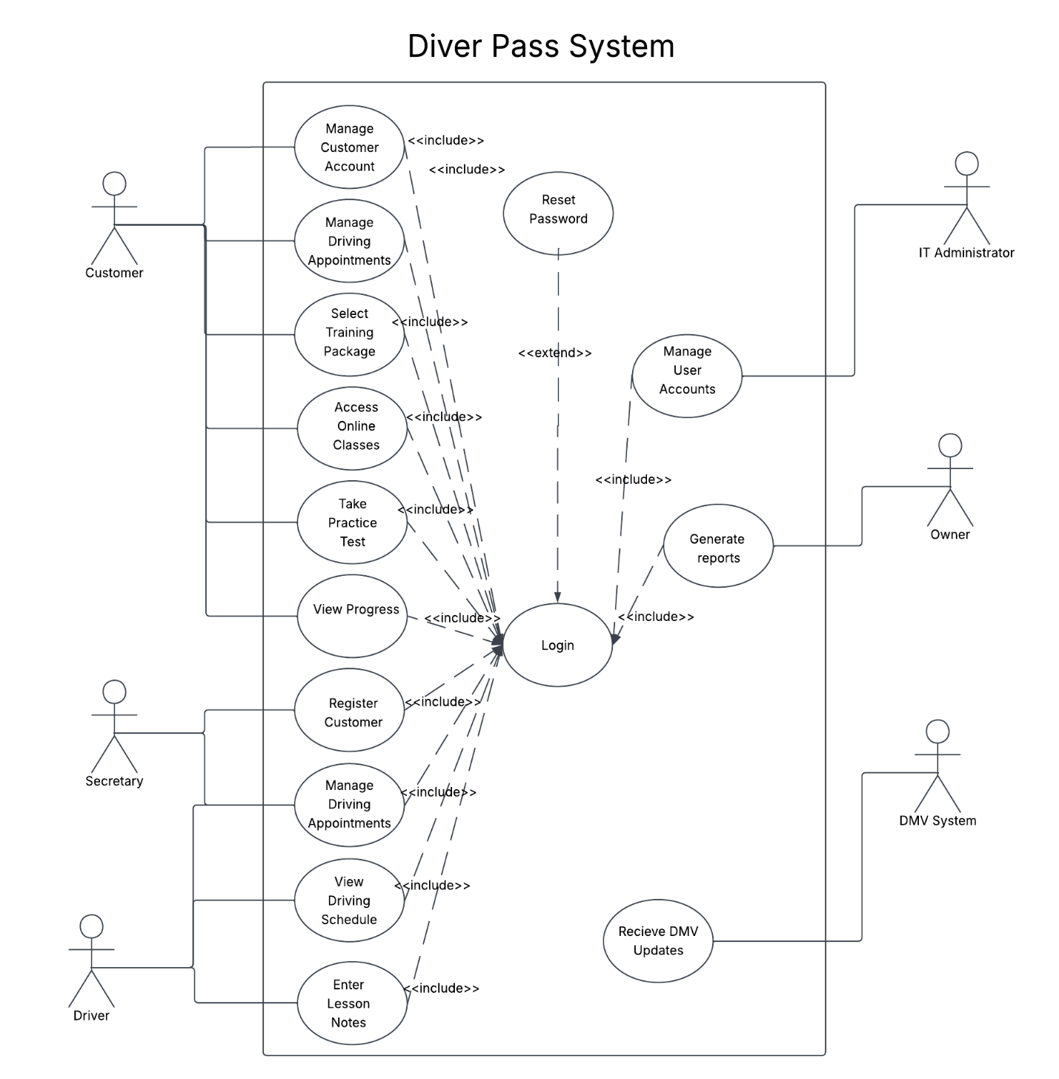

UML Activity Diagrams
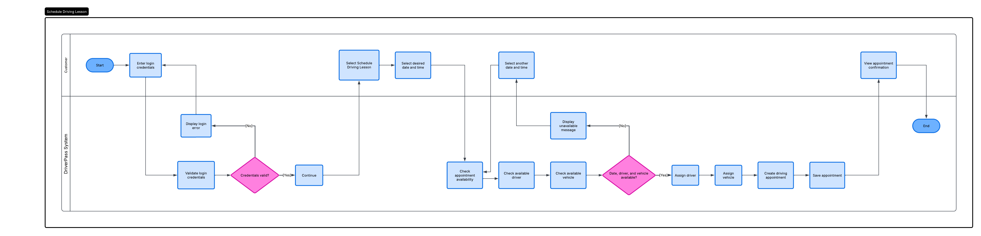
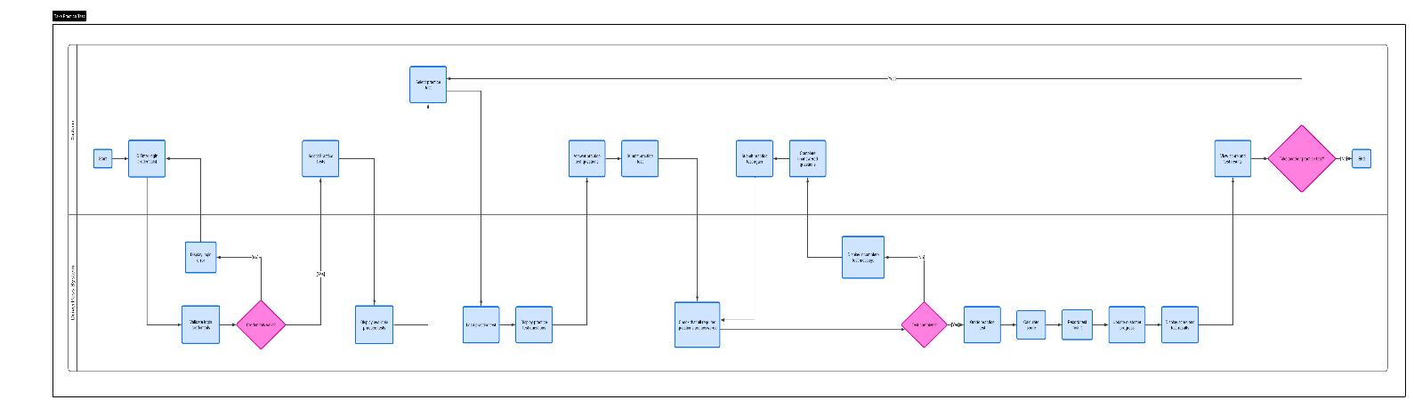

UML Sequence Diagram
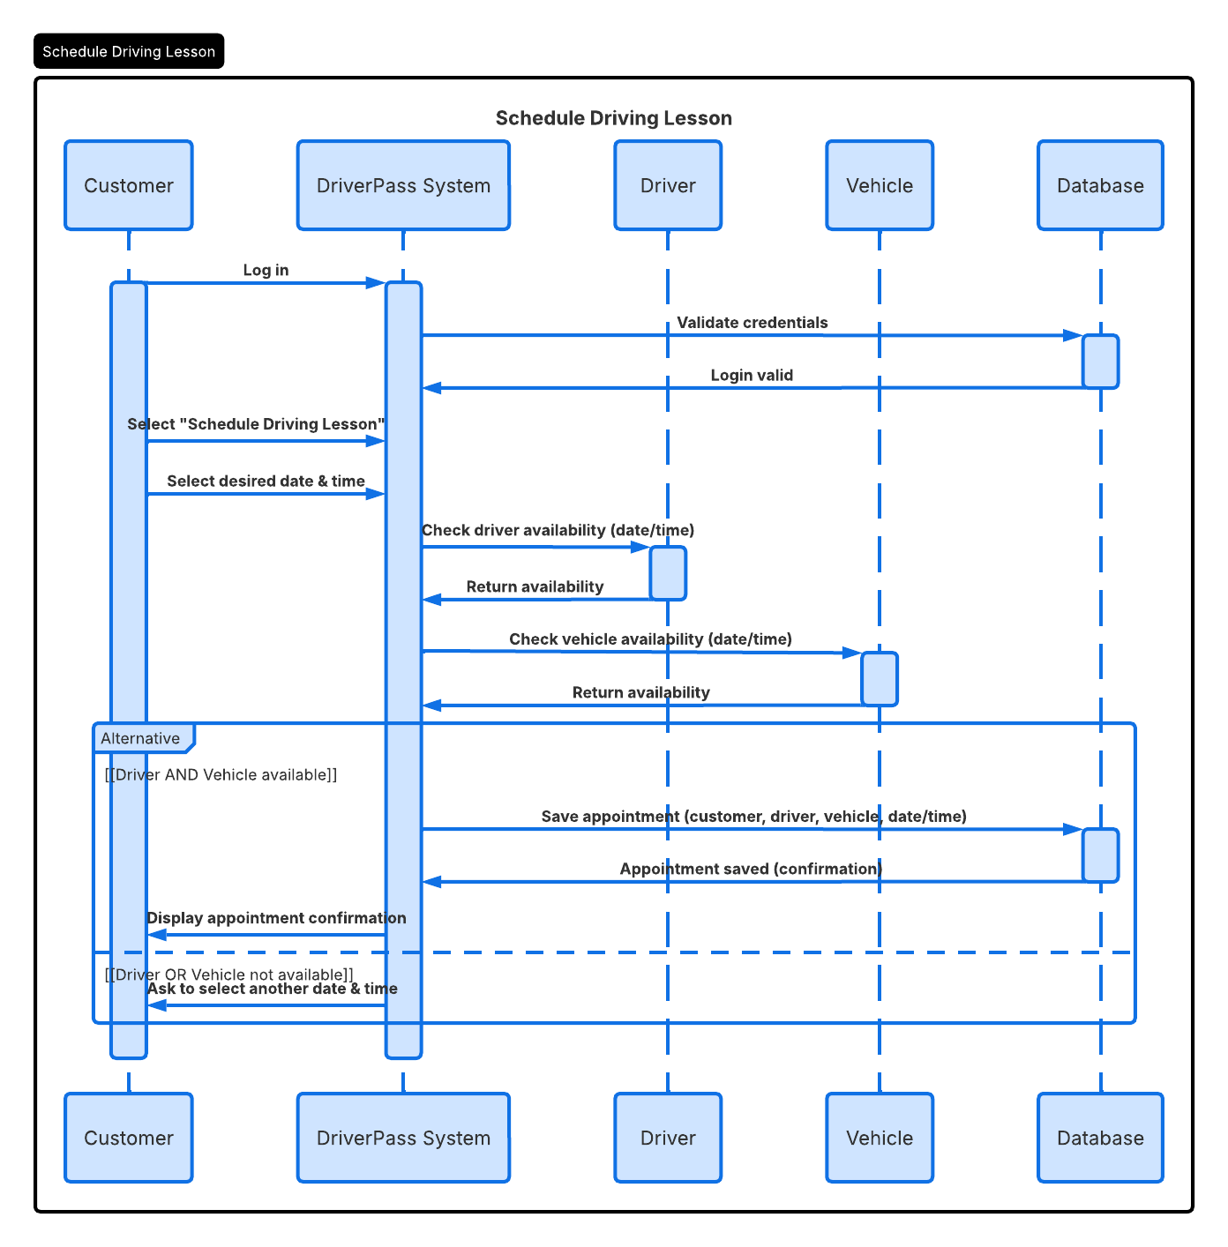

UML Class Diagram
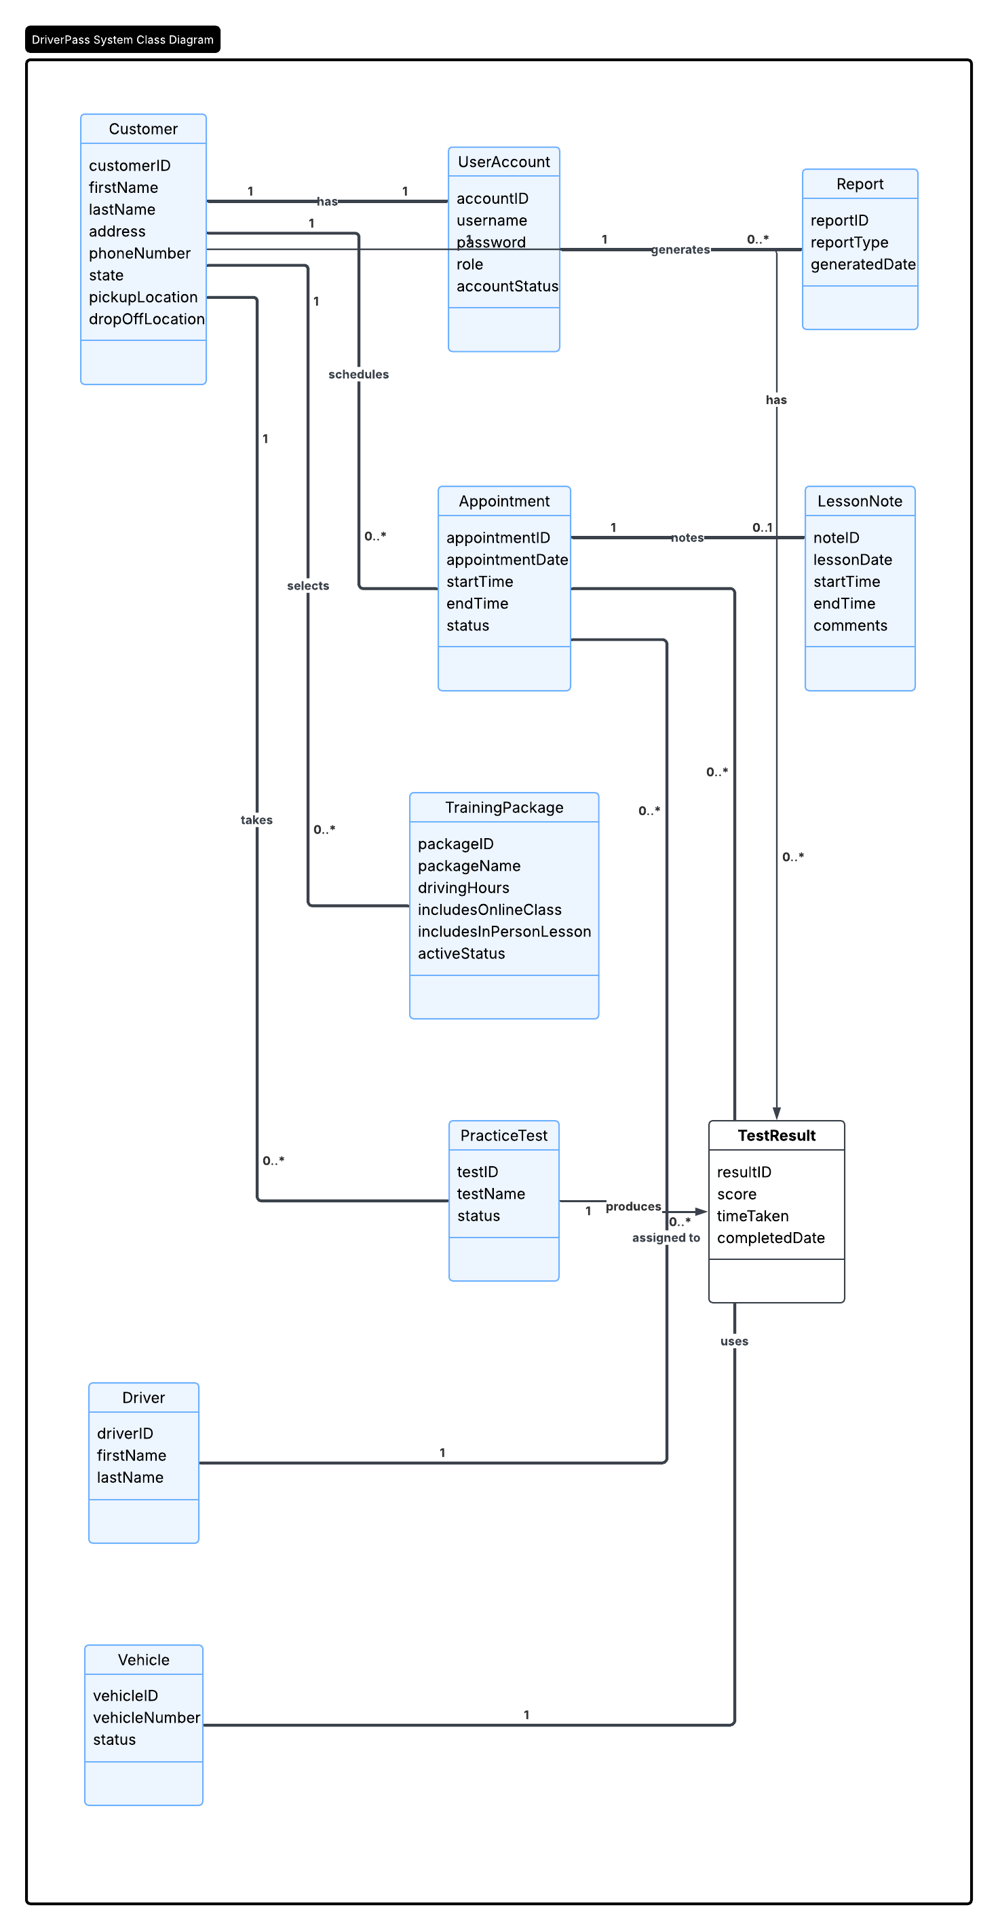

Technical Requirements
To use the DriverPass system employees will need computers that have an internet connection. Customers should be able to use their computers, smartphones or tablets to get into the system. The system is on the web. It works with Windows, macOS, Android and iOS. It should also work with browsers like Chrome, Edge, Firefox and Safari. We will use a MySQL database to store all the information about customer accounts, appointments, training packages, driver and vehicle information, lesson notes and practice test results. The DriverPass system will be online so customers and employees can get to it from anywhere. The cloud service we use will also make sure we have backups, so we do not lose any information. The DriverPass system will be safe because it will use HTTPS to protect the information that users send to the server. Users will have levels of access based on what they do and if someone tries to log in too many times with the wrong password their account will be locked for a little while. The DriverPass system will also get updates from the DMV. Our practice tests, rules and policies will always be current. When it comes to performance the DriverPass system should update appointment information away. The DriverPass system should also check if a driver and a vehicle are available before we confirm a lesson, with the DriverPass system.

